Create CRUD operation with in memory Database

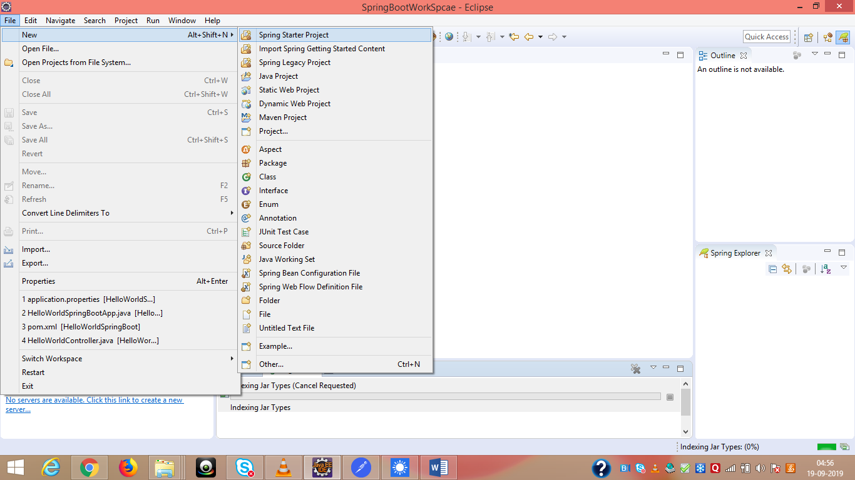

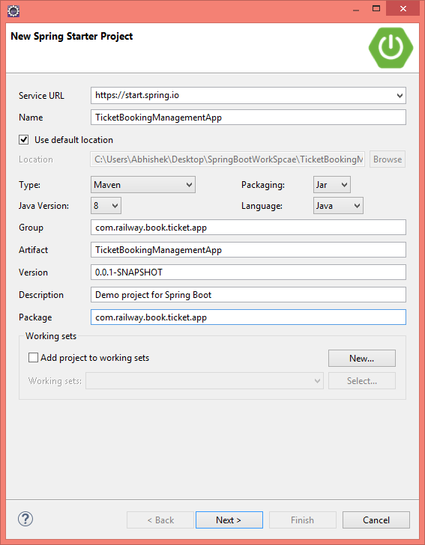

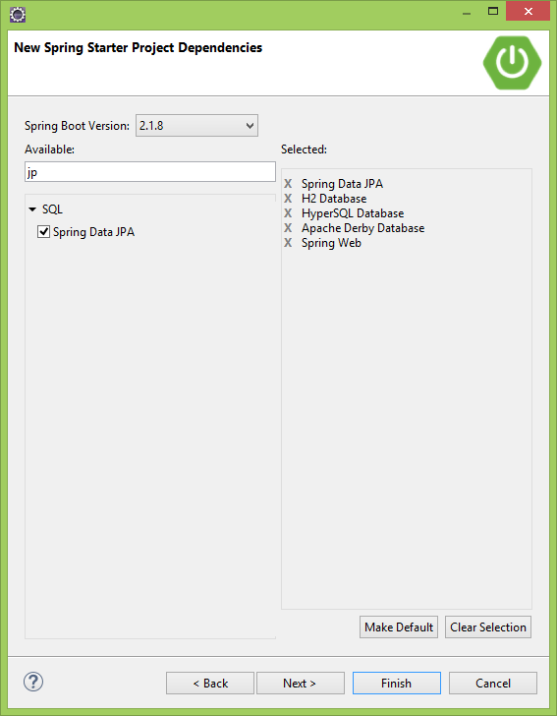

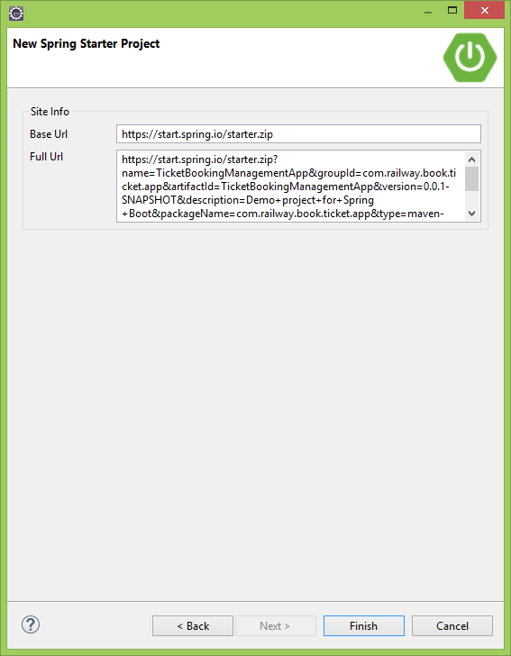

Finish

Change the Version

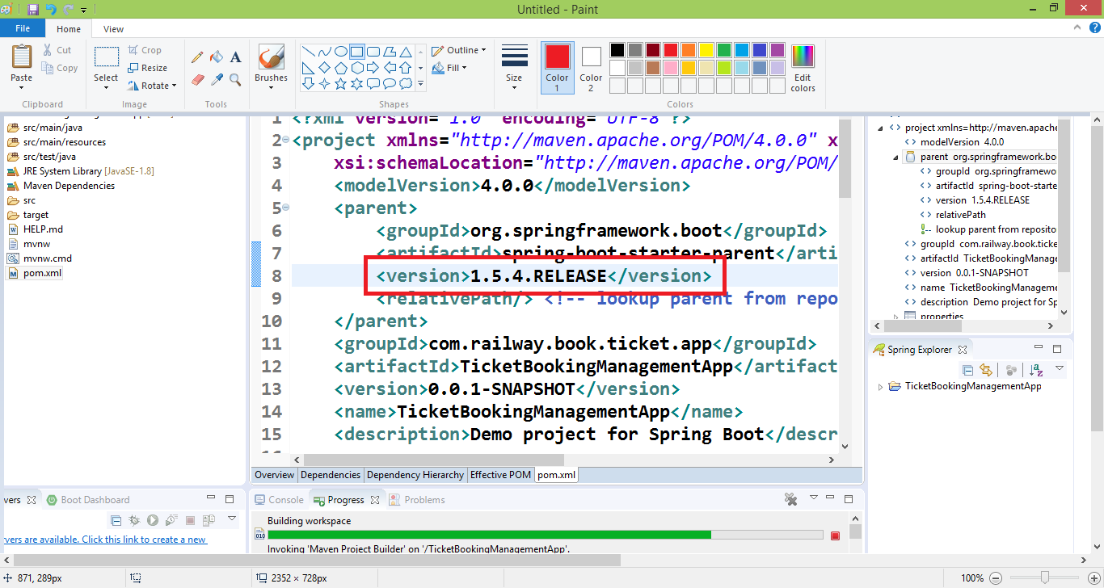

Update maven project

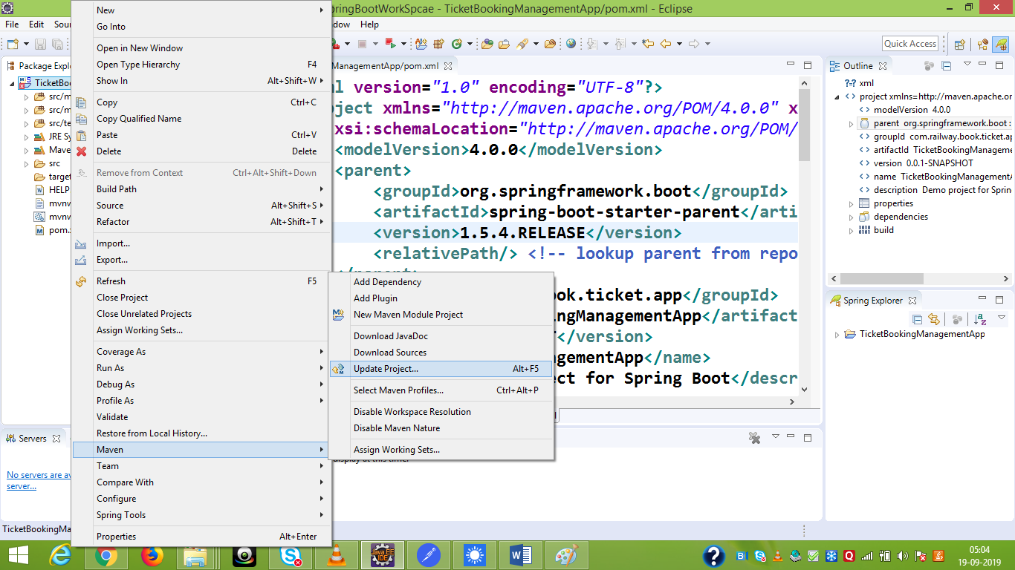

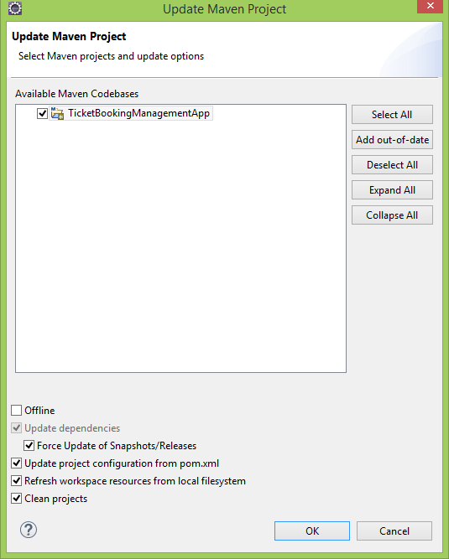

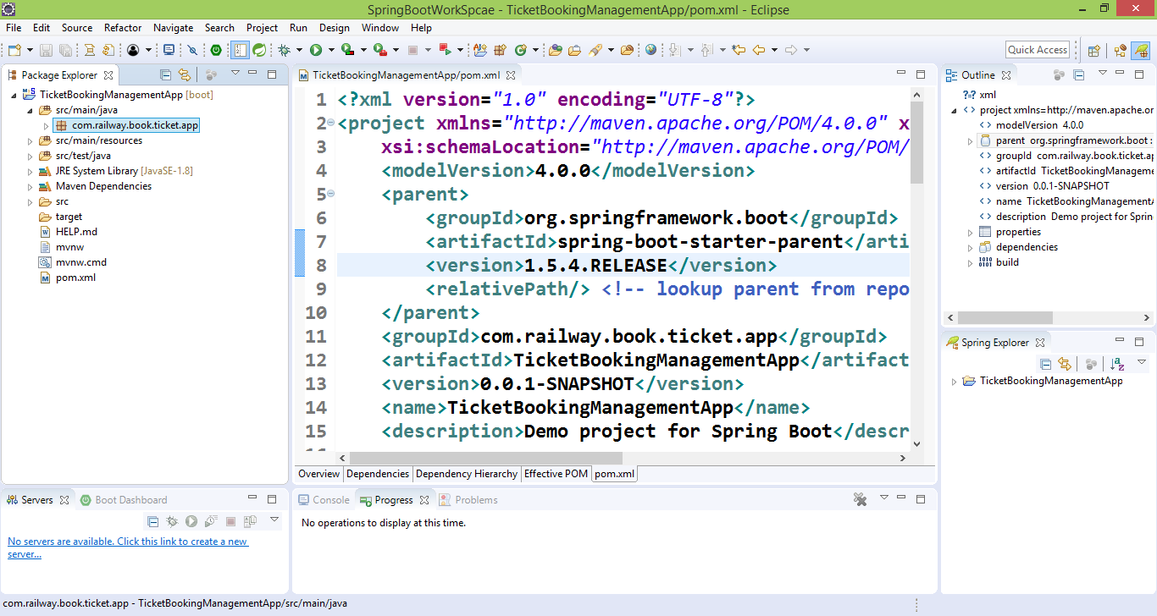

Create a class Ticket inside entities package

**package** com.railway.book.ticket.app.entities;

**import** java.util.Date;

**import** javax.persistence.Column;

**import** javax.persistence.Entity;

**import** javax.persistence.GeneratedValue;

**import** javax.persistence.GenerationType;

**import** javax.persistence.Id;

**import** javax.persistence.Table;

@Entity

@Table(name="ticket")

**public** **class** Ticket {

@Id

@GeneratedValue(strategy=GenerationType.***AUTO***)

@Column(name="ticket_id")

**private** Integer ticketId;

@Column(name="passenger_name",nullable=**false**)

**private** String passengerName;

@Column(name="booking_date")

**private** Date bookingDate;

@Column(name="source_station")

**private** String sourceStation;

@Column(name="destination_station")

**private** String destinatioStation;

@Column(name="email")

**private** String email;

**public** Integer getTicketId() {

**return** ticketId;

}

**public** **void** setTicketId(Integer ticketId) {

**this**.ticketId = ticketId;

}

**public** String getDestinatioStation() {

**return** destinatioStation;

}

**public** **void** setDestinatioStation(String destinatioStation) {

**this**.destinatioStation = destinatioStation;

}

**public** String getPassengerName() {

**return** passengerName;

}

**public** **void** setPassengerName(String passengerName) {

**this**.passengerName = passengerName;

}

**public** Date getBookingDate() {

**return** bookingDate;

}

**public** **void** setBookingDate(Date bookingDate) {

**this**.bookingDate = bookingDate;

}

**public** String getSourceStation() {

**return** sourceStation;

}

**public** **void** setSourceStation(String sourceStation) {

**this**.sourceStation = sourceStation;

}

**public** String getEmail() {

**return** email;

}

**public** **void** setEmail(String email) {

**this**.email = email;

}

}

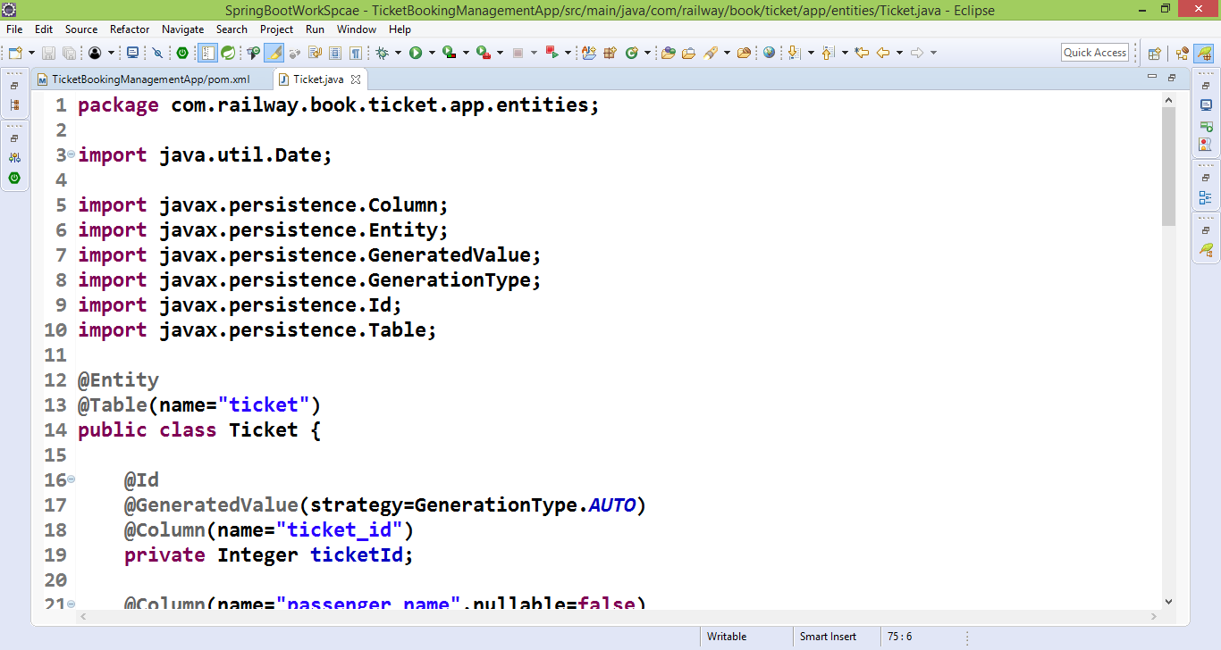

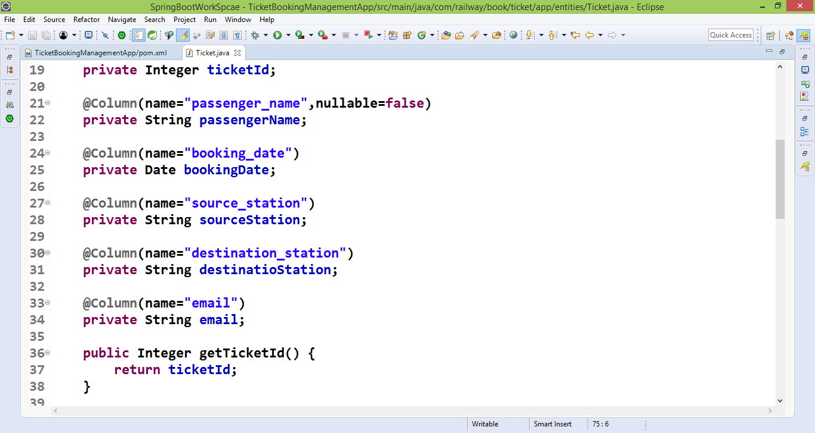

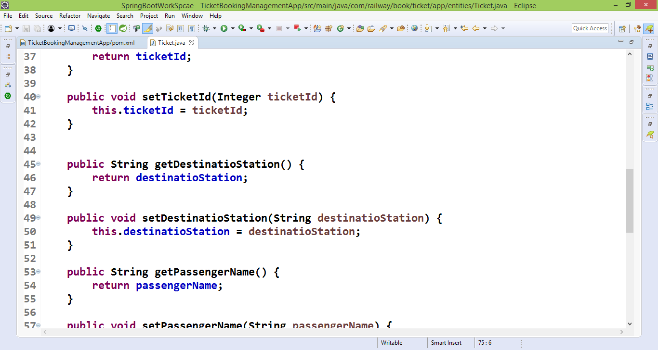

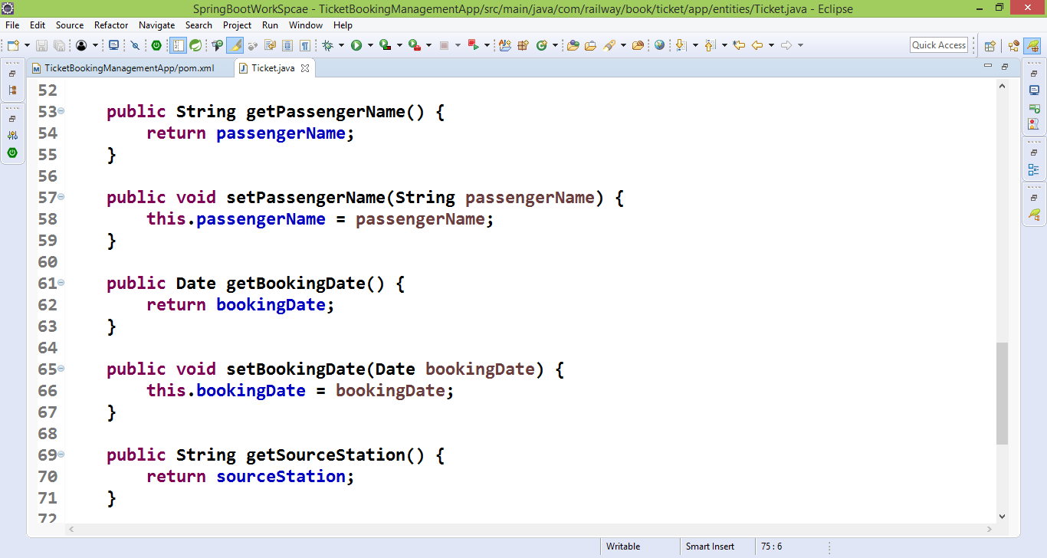

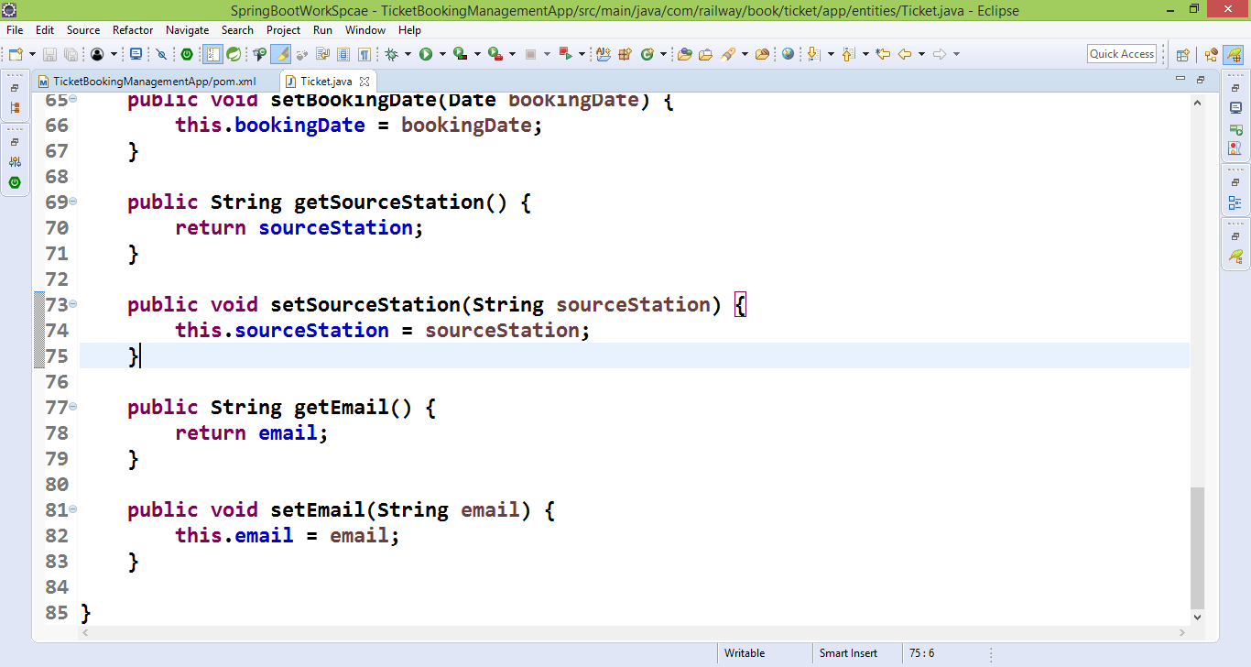

Create a service class

TicketBookingService

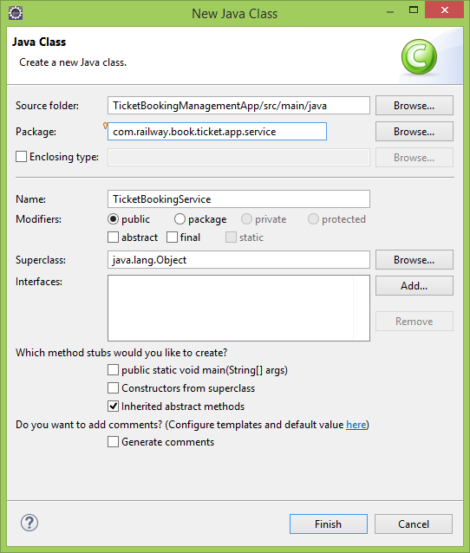

Mark this class as a @service

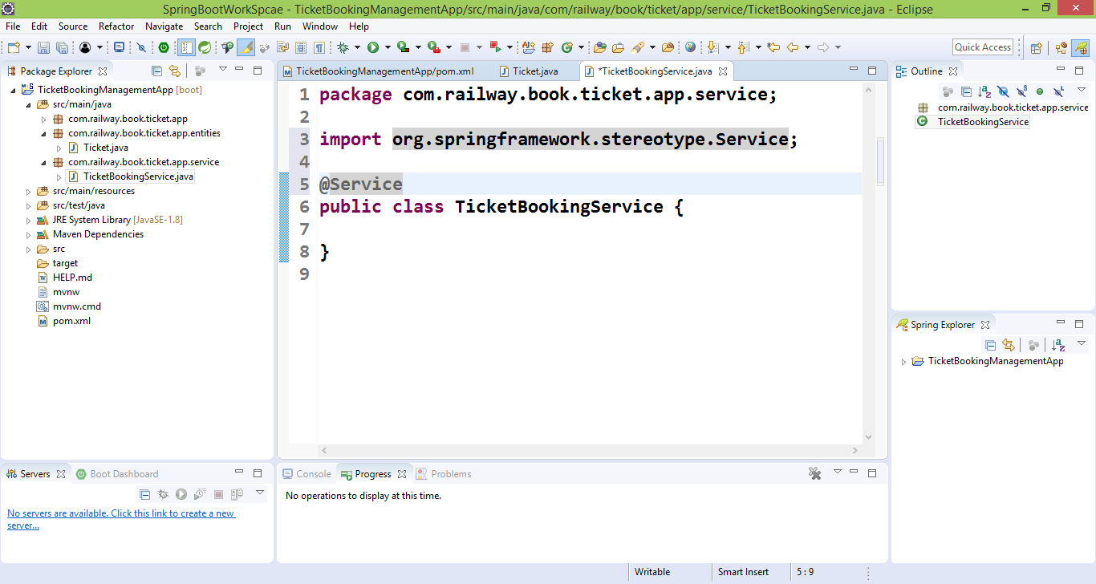

Create a DAO interface

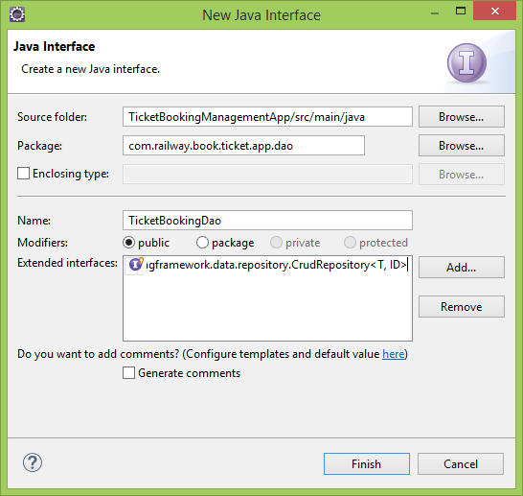

Mark this as a @Repository

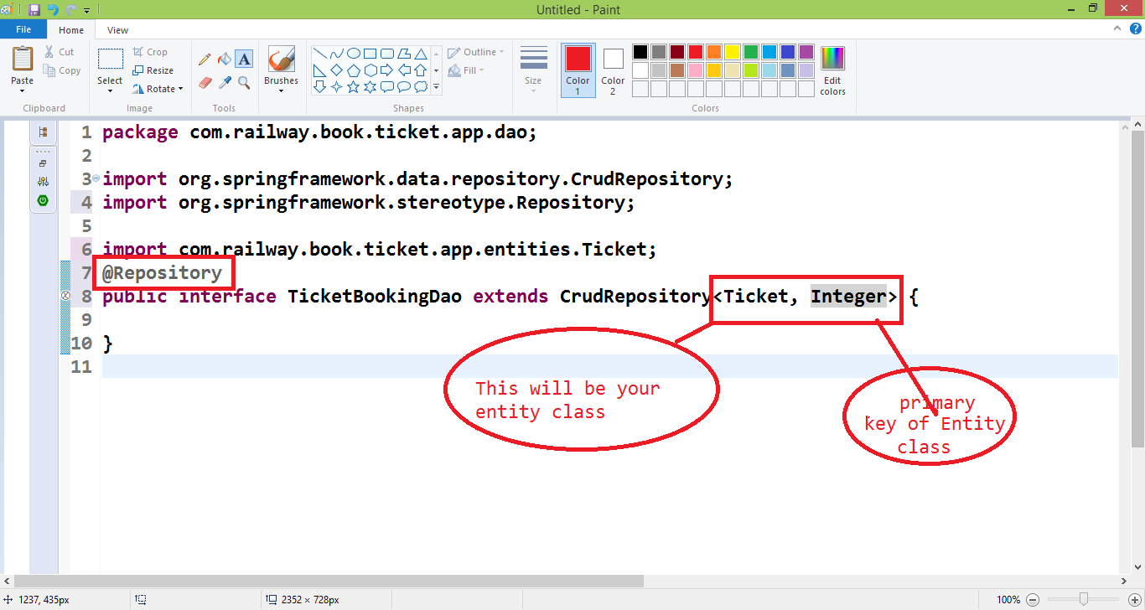

Create a Controller class

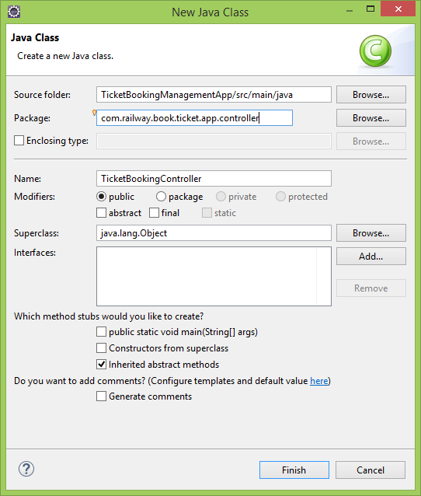

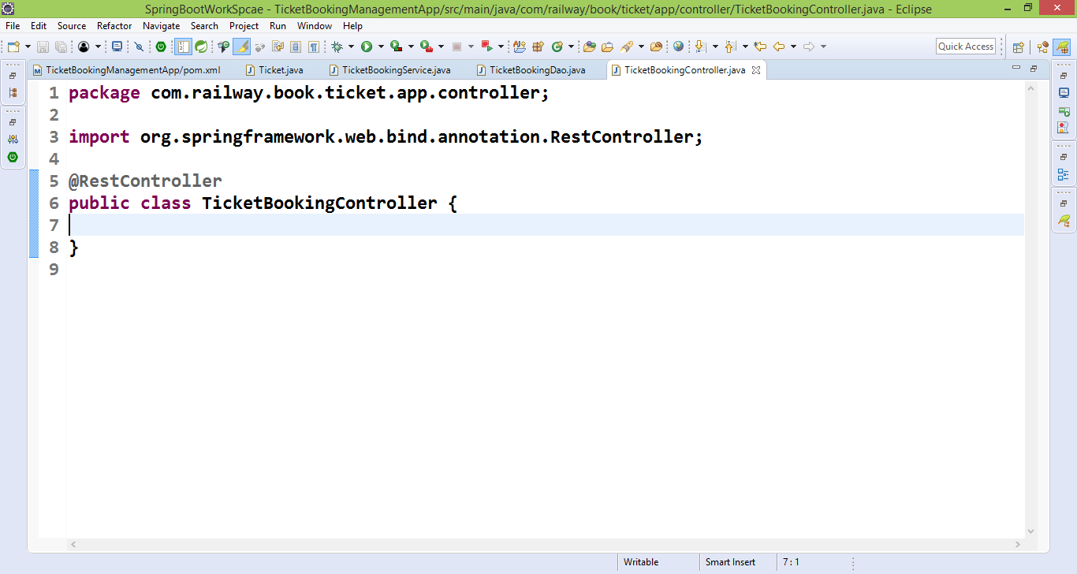

Write method to create and get in Controller and service

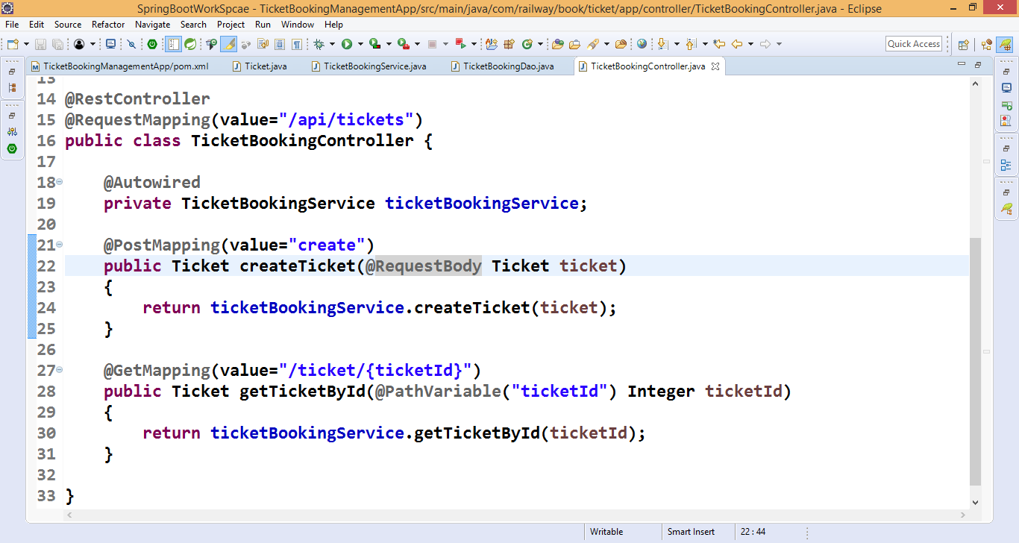

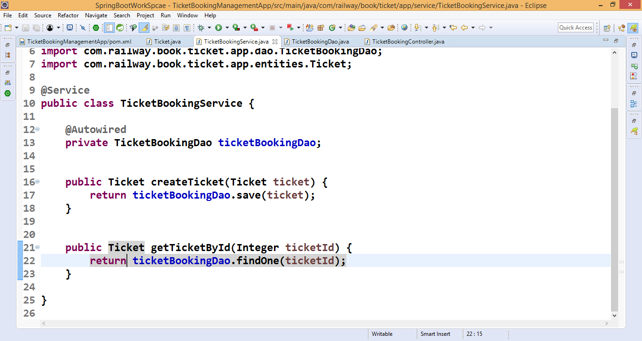

Create Ticket

Select POST method

Set Header

<http://localhost:8080/api/tickets/create>

{

"passengerName": "Aaradhya Bhardwaj",

"bookingDate": 1568848242243,

"sourceStation": "Delhi",

"destinatioStation": "Mumbai",

"email": "aaradhya@gmail.com"

}

To verify that call get method

<http://localhost:8080/api/tickets/ticket/1>

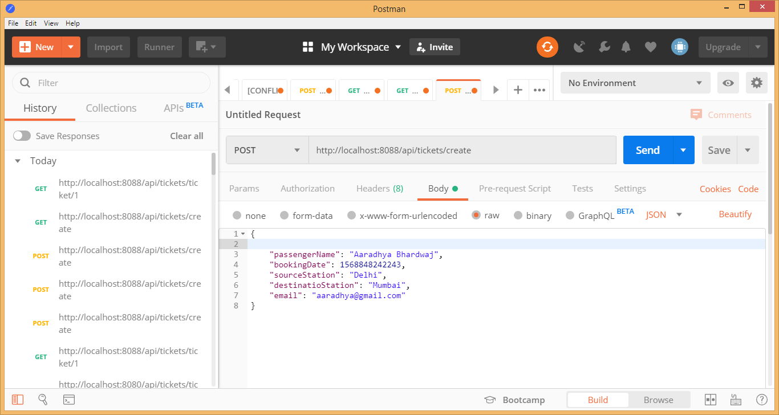

Write two more method in service

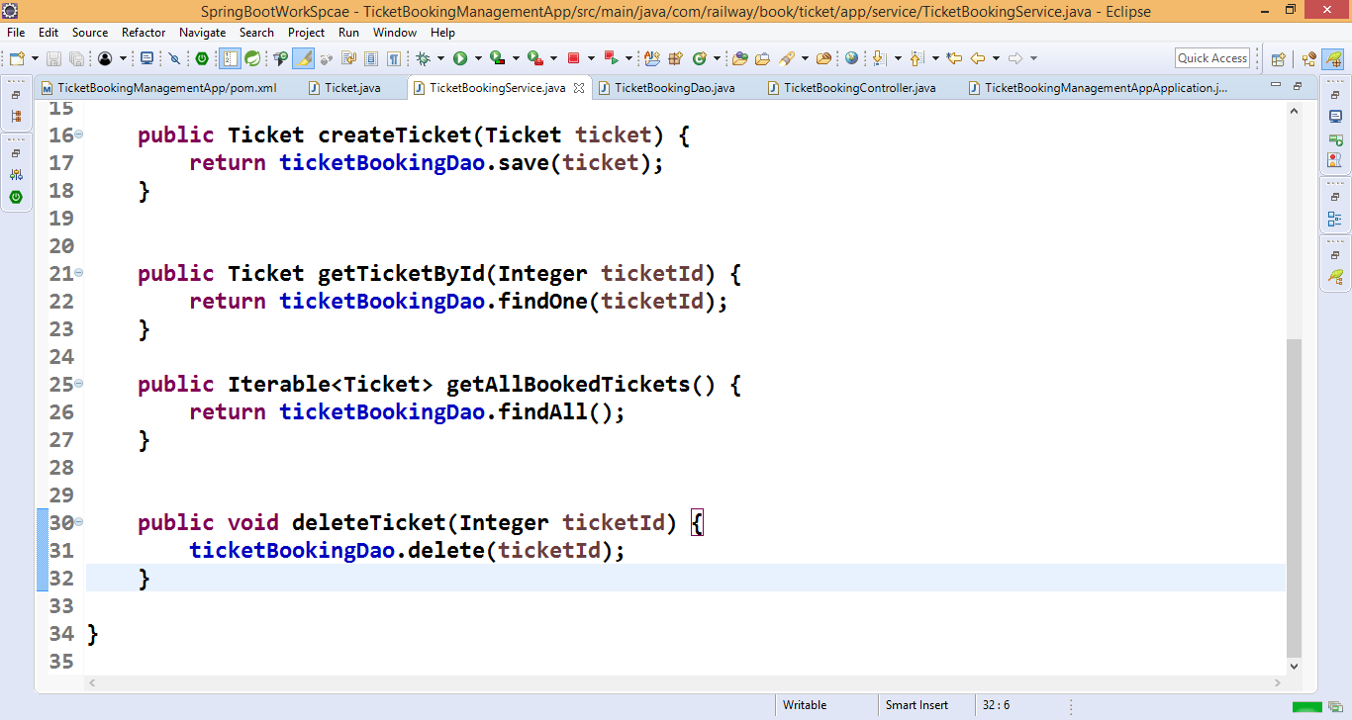

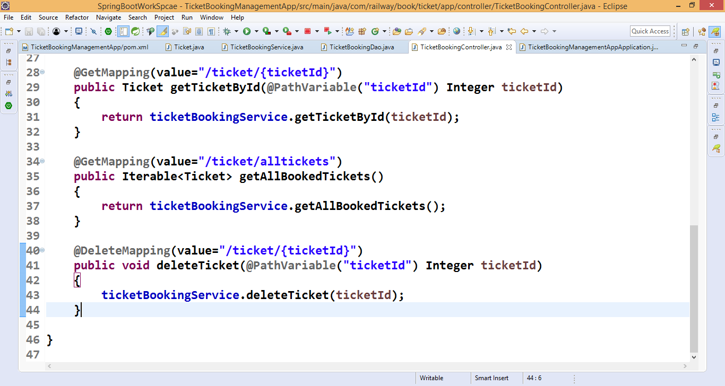

Check all

http://localhost:8080/api/tickets/ticket/alltickets

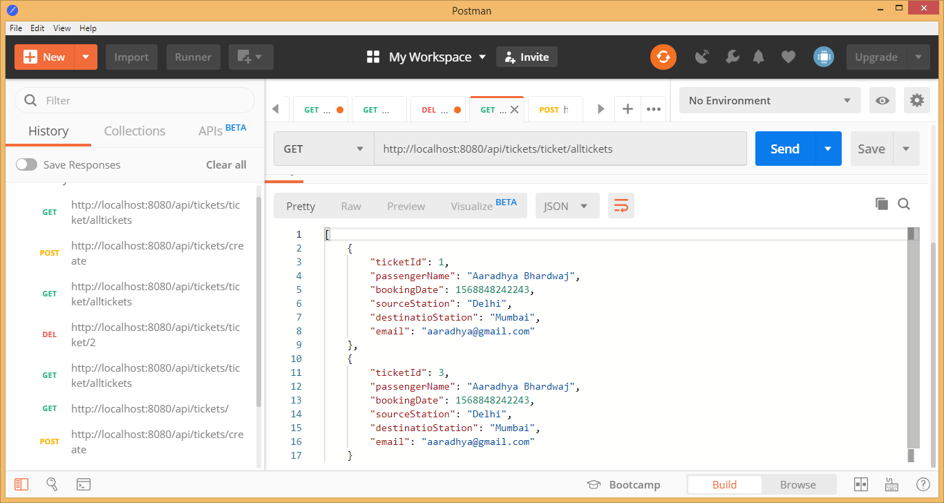

Check delete

<http://localhost:8080/api/tickets/ticket/2>

write for update

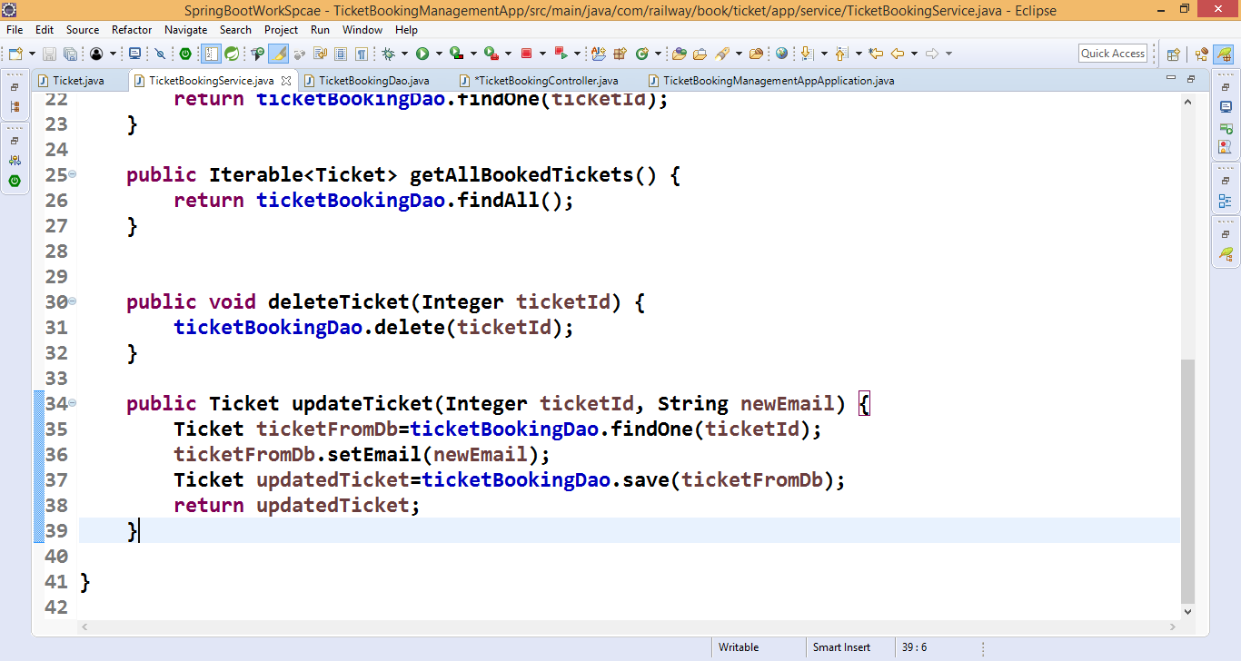

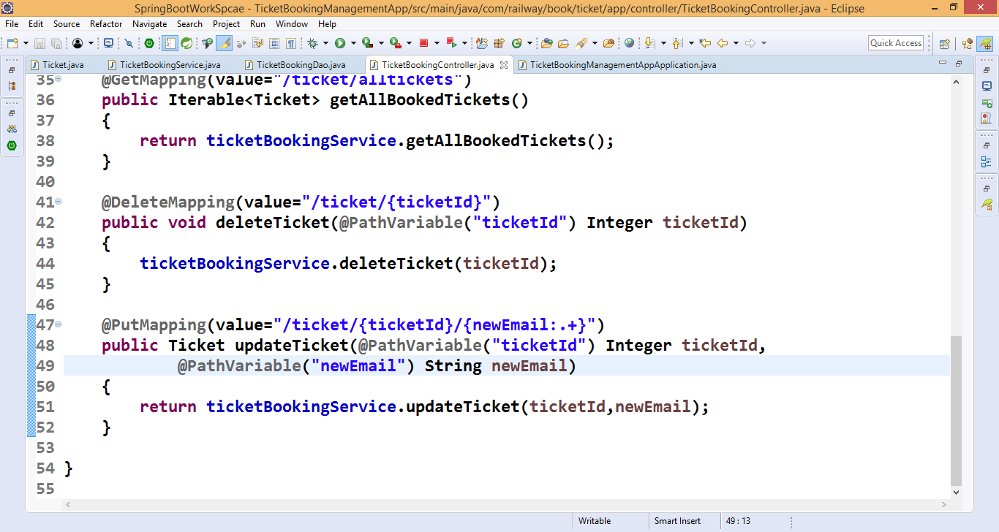

Check update

http://localhost:8080/api/tickets/ticket/1/aaradhya.2017@yahoo.com